Ideation Phase

Brainstorm & Idea Prioritization Template

|  |  |
| --- | --- |
| Date | 21 October 2022 |
| Team ID | PNT2022TMID51225 |
| Project Name | Project - Signs with Smart Connectivity for  Better Road Safety |
| Maximum Marks | 4 Marks |

**Brainstorm & Idea Prioritization Template:**

Brainstorming provides a free and open environment that encourages everyone within a team to participate in the creative thinking process that leads to problem solving. Prioritizing volume over value, out-of-the-box ideas are welcome and built upon, and all participants are encouraged to collaborate, helping each other develop a rich amount of creative solutions.

Reference:

<https://app.mural.co/invitation/mural/rsworkspace3113/1663336861920?sender=u617c2a5ea326f4c07b2a0274&key=8b6e1b17-3d34-4a77-8ace-7a8a8018a7de>

**Step1:** Team Gathering, Collaboration and select the problem statement

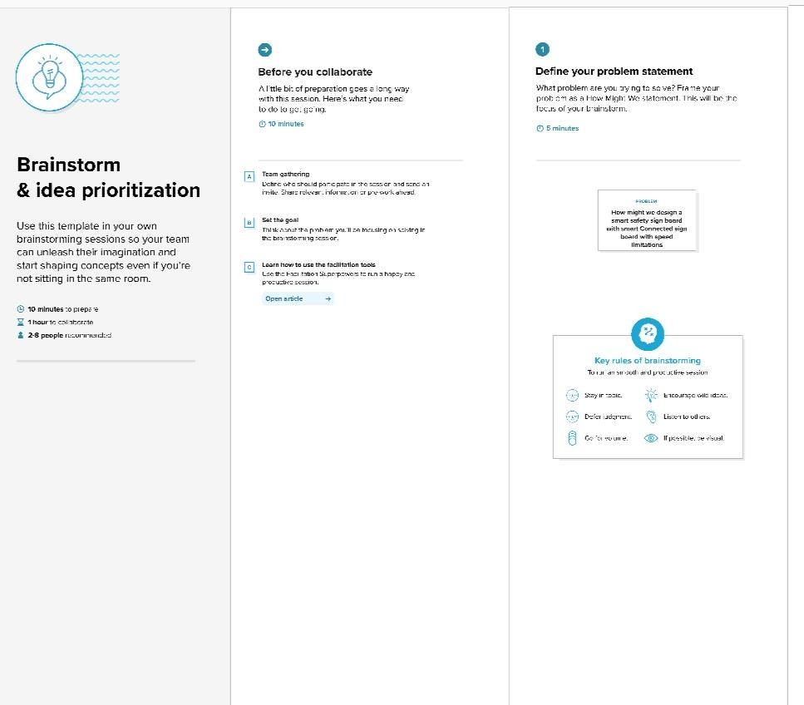

**Step2:** Brainstorm, Idea Listing and Grouping

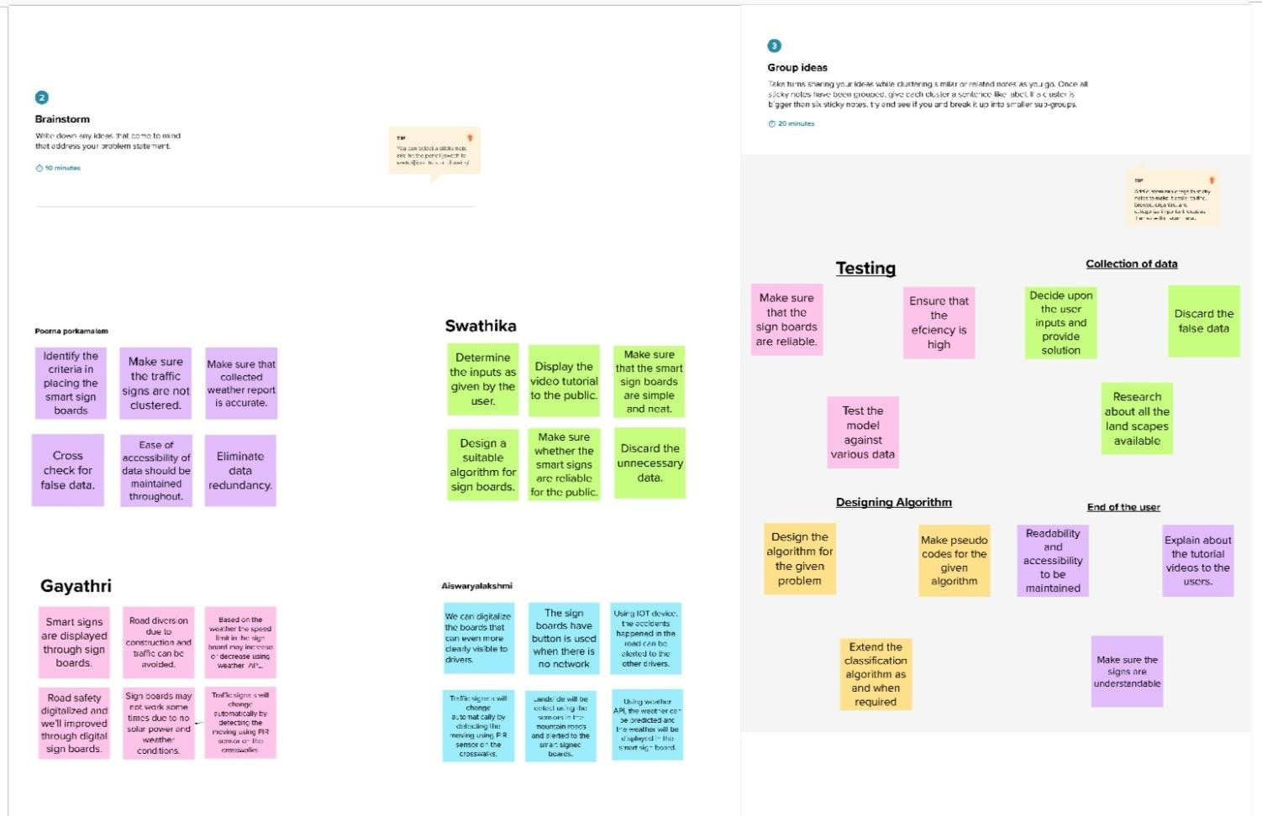

**Step 3:** Idea Prioritization

